K-Nearest Neighbors

Instructions:
Please share your answers filled in-line in the word document. Submit code separately wherever applicable.


Please ensure you update all the details:
Name: _____________ Batch ID: ___________
Topic: K-Nearest Neighbors

Hints:

- Business Problem
  - What is the business objective?
  - Are there any constraints?

- Work on each feature of the dataset to create a data dictionary as displayed in the below image:
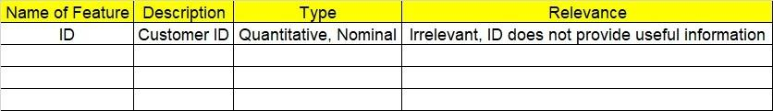

2.1 Make a table as shown above and provide information about the features such as its data type and its relevance to the model building. And if not relevant, provide reasons and a description of the feature.

- Data Pre-processing
3.1 Data Cleaning, Feature Engineering, etc.
- Exploratory Data Analysis (EDA):
  - Summary.
  - Univariate analysis.
  - Bivariate analysis.

- Model Building
  - Build the model on the scaled data (try multiple options).
  - Perform KNN and use cross validation techniques to get optimum K value.
  - Train and test the model and perform cross validation techniques. Compare accuracies, precision and recall and explain them in the documentation.
  - Briefly explain the model output in the documentation.

- Write about the benefits/impact of the solution - in what way does the business (client) benefit from the solution provided?


- A glass manufacturing plant uses different earth elements to design new glass materials based on customer requirements. For that, they would like to automate the process of classification as it’s a tedious job to manually classify them. Help the company achieve its objective by correctly classifying the glass type based on the other features using KNN algorithm.

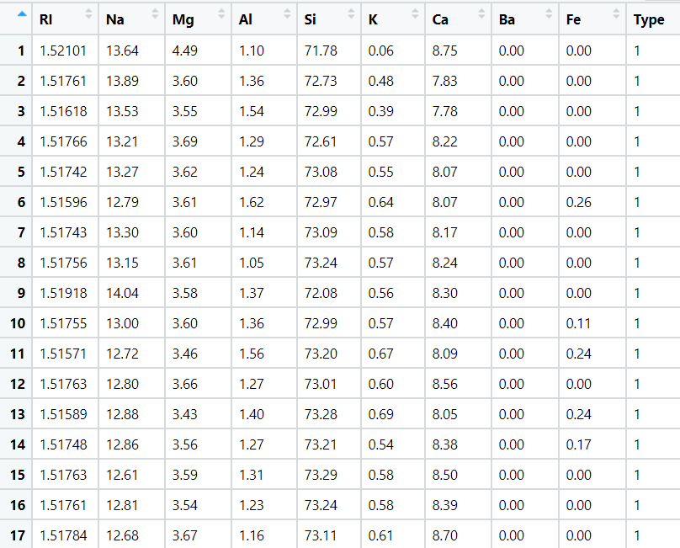


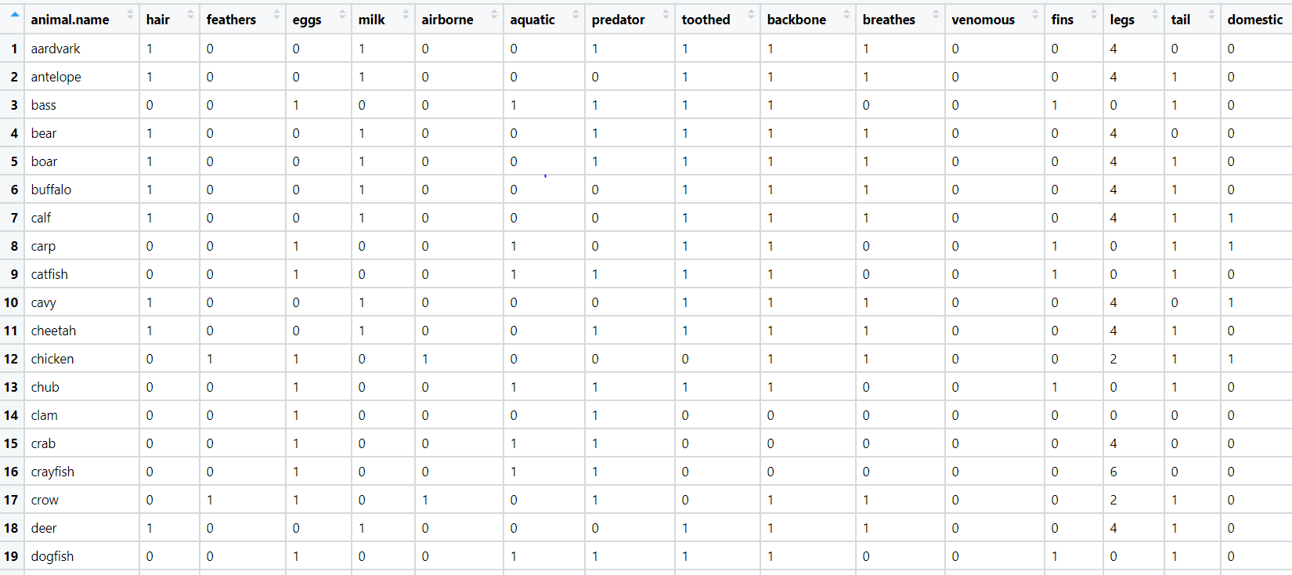
- A National Zoopark in India is dealing with the problem of segregation of the animals based on the different attributes they have. Build a KNN model to automatically classify the animals. Explain any inferences you draw in the documentation.

